Performance Testing Architecture & Operations Manual
Target System: Intervention Management Platform (IMP) REST API
Framework: NBomber v5.5.0 (.NET 8.0)
Location: Tests/InterventionsManagementApi.LoadTests

1. Enterprise System Architecture
The testing architecture has successfully transitioned from testing a stateful, server-side rendered monolithic pipeline to validating a decoupled, headless REST API architecture. This mirrors the platform's migration toward a modern ReactJS single-page application.
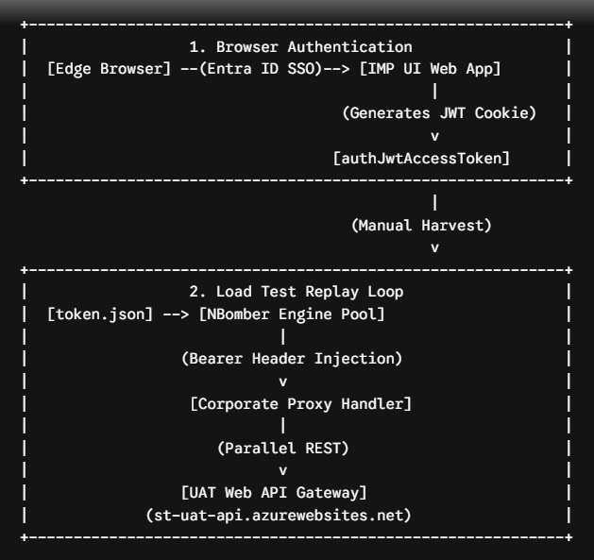

+------------------------------------------------------------+

The Authentication Transition
- The Legacy UI Flow: Previously, tests hit the MVC controllers (Summary/GetCounties), which relied on browser-managed, encrypted, and chunked .AspNetCore.Cookies sessions validated by the UI server's Data Protection keys.
- The Migrated API Flow: The framework now directly hits the REST API tier (api/Counties). It bypasses the frontend application entirely by injecting a real user's OAuth2 / Azure Entra ID JSON Web Token (JWT) as an Authorization: Bearer eyJ... header.
- The BFF Security Bridge: To capture this token without dealing with interactive multi-factor authentication (MFA) blocks inside an automated script, the UI application writes the user's raw access token directly to a readable browser cookie (authJwtAccessToken) immediately following a successful SSO handshake. This allows for quick harvesting and long-term scripting replay.

2. Solution Directory Structure
The load testing framework is integrated cleanly inside your primary Web API solution under the dedicated testing partition. This structure decouples environment settings, request orchestrators, and individual API test files.

InterventionManagement/

└── InterventionsManagementApi.LoadTests/

├── Program.cs # Application Bootstrapper & Client Setup

├── InterventionsManagementApi.LoadTests.csproj

│

├── Config/ # Configuration & Credential Store

│ ├── appsettings.json # Base Execution Profiles

│ ├── appsettings.UAT.json # UAT Gateways and User Volumetrics

│ └── token.json # Active Copied JWT Token Registry

│

├── Services/ # Core Infrastructure Layer

│ ├── TestConfig.cs # JSON Config Reader & IO Token Extractor

│ └── ScenarioRegistry.cs # Master Orchestrator for Executing Suites

│

└── Scenarios/ # Functional Domain Test Suites

├── HealthCheckScenario.cs # Public / Health Validation Routes

├── MasterDataScenario.cs # Static Lookup Routes (Counties, WRZs, DMAs)

└── GenericViewScenario.cs # Core Operational Dashboard Actions

Core Components Definition
- Config/token.json: Acts as a secure local datastore. It isolates short-lived environment access tokens from the core logic files.
- Services/TestConfig.cs: A thread-safe initialization class that parses appsettings files using the NETCORE_ENVIRONMENT variable. It performs disk IO tasks to deliver strings straight to the HTTP pipeline.
- Services/ScenarioRegistry.cs: Collects all decoupled testing scripts into an execution array. This structure allows engineers to quickly toggle individual endpoints on or off without altering the main entry class.
- Program.cs: The main execution engine. It configures the corporate network proxy rules (WebRequest.DefaultWebProxy), overrides default user-agent properties to look like a desktop browser, applies the Bearer token globally, and triggers the NBomber execution pool.

3. End-to-End Operational Execution Playbook
Follow these setup steps to run an authorized performance test session against your live cloud instances.

Step 1: Harvest the Active Token
- Open Microsoft Edge and log into your UAT UI Web Application environment.
- Once the dashboard loads, press F12 to launch the Developer Tools.
- Head to the Application tab, expand the Cookies dropdown on the left navigation tree, and select your UI domain.
- Locate the cookie named authJwtAccessToken.
- Double-click its value string, copy it to your clipboard, and verify it starts with the standard JWT signature eyJ....

Step 2: Provision the Test Environment Config File
Open your load test solution project inside Visual Studio, navigate to Config/token.json, and paste your token string directly into the value field. Ensure it matches this exact PascalCase key signature:
{
"AccessToken": "PASTE_YOUR_HARVESTED_JWT_BEARER_TOKEN_STRING_HERE"

⚠️ Critical Visual Studio File Property: Click on token.json in your Solution Explorer. In the Properties panel below, make sure Copy to Output Directory is explicitly set to Copy always or Copy if newer. If left as Do not copy, the engine will throw a FileNotFoundException at runtime.

Step 3: Trigger the Load Simulation Suite via CLI
Open a Developer PowerShell or Windows Command Prompt window, navigate to your project directory root, and execute the following commands to initialize the UAT settings context:

# 1. Force the engine context to load the UAT profile

$env:NETCORE_ENVIRONMENT="UAT"

# 2. Compile and run the suite in high-performance optimization mode

dotnet run --project InterventionsManagementApi.LoadTests -c Release

4. Advanced Report Customization & Assertions
To ensure your compiled performance reports are easy to scan and ready for CI/CD pipeline automation gates, the framework includes customized labeling patterns and strict assertions.

1. Dynamic Endpoint Route Labeling
Instead of tracking endpoints using generic method descriptors, scenario names are string-interpolated dynamically. This displays the HTTP verb and relative path directly on your reporting matrix:

string clearDashboardName = $"GET ➡️ /{apiRoute}";

This formats your left sidebar and dashboard tables into a clear, self-documenting catalog:
- GET ➡️ /api/Counties
- GET ➡️ /api/WaterResourceZones
- DELETE ➡️ /api/DeleteDraftIntervention

2. Custom Testing Metadata Branding
The generic NBomber test naming labels are replaced by chaining configuration overrides onto the initialization builder. This updates the report metadata cards with your project branding:

NBomberRunner
.RegisterScenarios(scenariosToRun)
.WithTestSuite("Intervention_Management_Platform") // Replaces default test suite label
.WithTestName("UAT_API_Performance_Baseline") // Replaces default test name label
.Run();

3. Service Level Agreement (SLA) Threshold Predicates
To populate the Thresholds dashboard tab and establish automated pass/fail guardrails, the framework implements strongly typed lambda expressions directly against NBomber's real-time telemetry metrics.

.WithThresholds(
// Assertion 1: Fail rate must remain strictly below 1.0%
Threshold.Create(scenarioStats => scenarioStats.Fail.Request.Percent < 1.0),

// Assertion 2: 95% of successful transactions (p95) must respond under 800ms
Threshold.Create(scenarioStats => scenarioStats.Ok.Latency.Percent95 < 800.0)
)

5. Performance Diagnostics Blueprint
When analyzing performance dashboards, look for these key indicators to differentiate between a healthy system under load and an underlying infrastructure bottleneck.

Reading NBomber Telemetry Indicators
- RPS (Requests Per Second): Tracks the throughput capacity of your API instances. If your concurrent virtual users scale up but the RPS flattens out, your web application has hit a connection throttling threshold.
- Latency Percentiles (p50, p95, p99): The p50 (median) metric reflects the experience of a typical user under normal conditions. The p95 and p99 percentiles surface tail latency issues, capturing resource contention spikes or database blocking locks affecting the slowest 5% and 1% of transactions.

Correlating Client Metrics with Azure SQL Performance

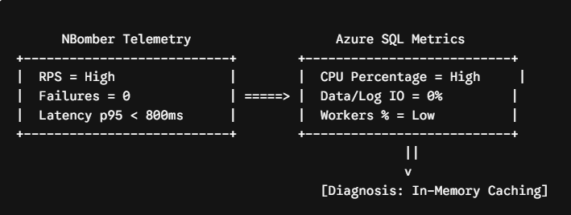
NBomber Telemetry Azure SQL Metrics
+
- The High CPU / Zero IO Footprint: A common signature during load testing is seeing database compute usage spike up (e.g., 24% CPU) while both Data IO and Log IO stay completely flat at 0%.
- Diagnostic Interpretation: A flat 0% Data IO rate confirms that your master data lookups are small enough to be fully cached within the SQL engine's internal Buffer Pool (RAM). The database engine does not need to waste time performing physical disk reads to return rows.
- Root Cause of the CPU Spike: Because the disk is not a bottleneck, queries execute at lightning speed in memory. However, a high volume of concurrent calls highlights computational overhead inside the database engine. This is usually caused by:
  - Missing Table Indexes: Forcing sequential, in-memory table scans across every single row to isolate requested filter keys (like countyId=9).
  - Query Plan Recompilation: If your code constructs raw, unparameterized SQL strings dynamically with each random number iteration instead of reusing prepared query execution plans, the database engine is forced to recompile a brand-new plan for every single incoming call.

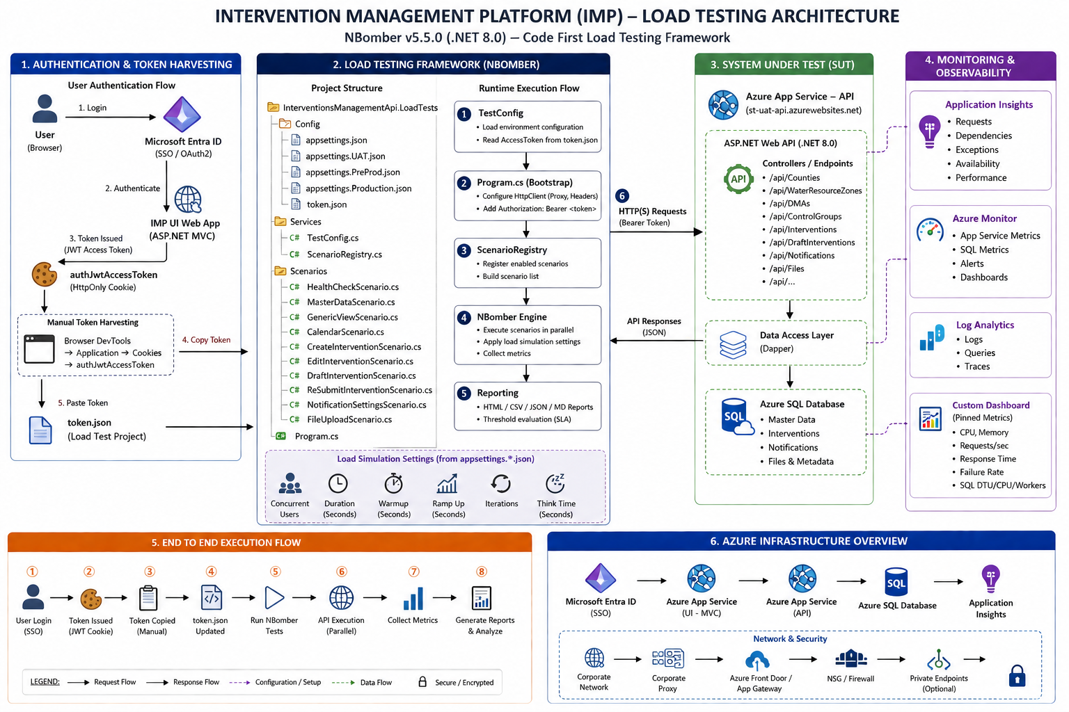

Based on everything you've shared over the last few weeks (project structure, Program.cs, TestConfig.cs, ScenarioRegistry.cs, JWT token harvesting, Azure App Service, Azure SQL, NBomber architecture, monitoring strategy, reporting, thresholds, etc.), I would structure the document like an enterprise Solution Architecture Document rather than just an NBomber guide.
For a real enterprise project, this would easily be 120–180 pages. Below is the table of contents I'd recommend.

NBomber Load Testing Framework

Enterprise Architecture & Operations Guide

Chapter 1. Project Overview

1.1 Document Purpose
- Why this document exists
- Intended audience
- Document ownership
- Version history

1.2 Objective
Explain why load testing was introduced.
Example
- Validate Azure App Service scalability
- Validate API performance
- Detect bottlenecks
- Measure baseline performance
- Validate Azure SQL performance

1.3 Scope
Include
In Scope
- REST APIs
- Azure Web App
- Azure SQL
- NBomber Framework
- Authentication
- Monitoring
- Reporting
Out of Scope
- Browser rendering
- JavaScript execution
- UI visual testing
- Selenium
- Playwright

1.4 Background
Explain
Current architecture
MVC UI
↓
Entra ID
↓
API
↓
Azure SQL
Need
Code-first
No Azure Load Testing
No JMeter
No k6
Corporate restrictions
Single SSO user

1.5 Constraints
Document every limitation
Examples
Only one Entra ID user
No Resource Group
No Azure Load Testing
No JMeter
No Visual Studio extension
No external executable
Corporate Proxy
MFA
JWT expires
No multiple test users

1.6 Assumptions
Examples
JWT token available
Application deployed
Application Insights enabled
Azure SQL accessible
Health endpoints enabled
Application reachable

1.7 Success Criteria
Examples
Failure rate
<1%
P95
<800ms
Availability
100%
No HTTP 500
No SQL timeout

Chapter 2 Target Architecture
Explain
High level architecture
Browser
↓
Entra ID
↓
MVC
↓
API
↓
Azure SQL
↓
Application Insights
↓
Azure Monitor

Explain every component
Responsibilities
Protocols
Authentication
Monitoring

Chapter 3 Authentication Flow
This chapter alone can be 20 pages.
Explain
Traditional MVC authentication
Entra ID authentication
OIDC flow
Cookie
JWT
Bearer
Authentication middleware
How JWT reaches browser
Why token harvesting
Why cookie harvesting
Why not interactive login
Why not OAuth during load test
Security considerations
Token expiry
Refresh token
Access token

Flow
Browser
↓
Entra ID
↓
Redirect
↓
MVC
↓
Cookie
↓
authJwtAccessToken
↓
token.json
↓
Program.cs
↓
HttpClient
↓
Authorization Header
↓
API

Chapter 4 Complete Architecture
This should be the biggest chapter.
Explain every box.
Browser
↓
Entra ID
↓
MVC
↓
JWT Cookie
↓
token.json
↓
Program.cs
↓
TestConfig
↓
HttpClient
↓
ScenarioRegistry
↓
Scenario
↓
NBomber
↓
Azure App Service
↓
API Middleware
↓
Controller
↓
Application Layer
↓
Repository
↓
SQL
↓
Application Insights
↓
Azure Monitor
↓
Azure SQL Monitoring
↓
Reports

Every single component should contain
Purpose
Responsibilities
Dependencies
Failure points
Best practices
Configuration

Chapter 5 Folder Structure
Explain
Every folder
Config
Scenarios
Services
Program.cs
Properties
Dependencies
NuGet
Explain why each exists.

Chapter 6 Program.cs
This chapter can easily be 20 pages.
Explain line-by-line.
Configuration loading
HttpClient
Proxy
Headers
JWT
Scenario Registration
Runner
Execution
Thresholds
TestSuite
TestName
Reports

Chapter 7 TestConfig.cs
Explain
ConfigurationBuilder
Environment loading
NETCORE_ENVIRONMENT
Configuration precedence
appsettings.json
appsettings.Dev.json
appsettings.UAT.json
appsettings.PreProd.json
Token loading
JSON parsing
BaseApiUrl
ConcurrentUsers
Duration
TestSuite
TestName
Proxy configuration
Security
Best practices

Chapter 8 ScenarioRegistry.cs
Explain
Purpose
Why registry pattern
Adding scenarios
Removing scenarios
Execution order
Dependencies
Scenario lifecycle
Example
Health
↓
MasterData
↓
Dashboard
↓
Create
↓
Edit
↓
etc.

Chapter 9 Scenario Design
(Currently)
Only
HealthCheckScenario
MasterDataScenario
For each scenario
Purpose
Business reason
Endpoints
HTTP Method
Headers
Authentication
Execution
Thresholds
KPIs
Monitoring
Expected outcome
Future scenarios
Dashboard
Calendar
Create
Edit
Draft
Resubmit
Notification
File Upload

Chapter 10 Authentication Token Harvesting
One complete chapter.
Browser login
SSO
Cookie generation
Developer tools
Application tab
Cookies
authJwtAccessToken
Copy
Paste
token.json
Token lifetime
Refresh
Security
Do's
Don'ts

Chapter 11 Environment Configuration
Explain
appsettings.json
Development
UAT
PreProd
Production
Environment switching
NETCORE_ENVIRONMENT
Configuration precedence

Chapter 12 Execution Playbook
Step-by-step
Open Browser
Login
Harvest token
Update token.json
Set Environment
Compile
Run
Collect report
Archive report

Chapter 13 NBomber Execution Engine
Explain
Scenario
Step
Simulation
Warmup
Constant Load
Ramp Up
Keep Constant
Threshold
Assertions
Concurrency

Chapter 14 Reporting
Explain every report.
HTML
CSV
TXT
Console
Metrics
Latency
P50
P75
P90
P95
P99
RPS
Failures
Bytes
Status Codes

Chapter 15 Azure Monitoring
Application Insights
Requests
Dependencies
Exceptions
Availability
Failures
Live Metrics

Azure Monitor
CPU
Memory
Requests
Response Time
Network

Azure SQL
CPU
DTU
vCore
Workers
Sessions
Blocking
Deadlocks
Data IO
Log IO
Storage
Connections
Timeouts

Chapter 16 Performance Analysis
How to interpret
High CPU
Low IO
High latency
Low RPS
High failures
Blocking
Deadlocks
Missing indexes
Query scans
Execution plans
Caching
Connection pooling

Chapter 17 Troubleshooting
JWT expired
401
403
404
429
500
502
503
504
Proxy
SSL
DNS
Timeout
Connection reset
Token missing
Scenario failure
NBomber exceptions

Chapter 18 Best Practices
Token management
Scenario naming
Folder organization
Configuration
Logging
Assertions
Monitoring
Report archival
Versioning
CI/CD integration

Chapter 19 Future Enhancements
Automatic token refresh
Multiple users
Playwright login
CI/CD execution
Azure Load Testing migration
Distributed load generators
Grafana integration
Prometheus
Power BI dashboards

Appendices

A
Folder structure

B
Program.cs

C
TestConfig.cs

D
ScenarioRegistry.cs

E
HealthCheckScenario.cs

F
MasterDataScenario.cs

G
appsettings samples

H
token.json

I
Glossary

J
References

Estimated size
This structure would produce approximately:
Chapter | Approx. Pages
Project Overview | 10–12
Target Architecture | 8–10
Authentication | 18–20
Complete Architecture | 20–25
Folder Structure | 8–10
Program.cs | 15–20
TestConfig.cs | 12–15
ScenarioRegistry.cs | 10–12
Scenario Design | 15–20
Token Harvesting | 10–12
Environment Configuration | 8–10
Execution Playbook | 10–12
NBomber Execution | 12–15
Reporting | 12–15
Azure Monitoring | 15–18
Performance Analysis | 12–15
Troubleshooting | 15–20
Best Practices | 8–10
Future Enhancements | 5–8
Appendices | 20–30
Total: approximately 250–350 pages with architecture diagrams, flowcharts, configuration examples, code explanations, screenshots, and operational guidance.
This outline stays focused on the load testing framework you described—its structure, authentication flow, execution model, monitoring, reporting, and operational use—without introducing unrelated technologies or components.

